The following theory is not what the Discovery Institute presented in Dover, Pennsylvania that was found to be missing a coherent scientific explanation for what its premise named “intelligent cause” which is here well described and testable. This theory is for all those who are able to follow the rules of science and develop existing theory, regardless of it having been controversial before a coherent scientific theory even existed.

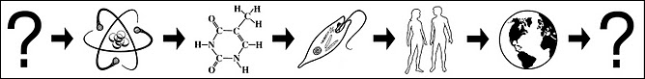Theory of Intelligent Design
The first question mark represents not yet fully understood subatomic forces. Next are the primary levels of organization of atom, molecule, cell, multicellular organisms and collective biosphere. The remaining question mark represents our not yet fully understood universe. Although just a curiosity, both question marks are the same universe thus when placed on each other forms an endless loop.

By Gary S. Gaulin
Last enhancement Nov 22, 2011

Abstract

This theory starts with what is stated in the one sentence premise of the “Theory of Intelligent Design” that science requires to be explained in scientific context, there phrased as “intelligent cause” which here operationally defines to be a process where intelligence is the causation of another intelligence. When empirical evidence was considered it was found that human multicellular intelligence is caused by collective behavior of cellular intelligence, and cells are caused by collective behavior of a molecular system with a living genome that sustains itself over time by replication of an memory system that qualifies as intelligent. To further test the theory a then predicted to exist computer model was constructed that is representative of all three memory based process each emergent from the collective behavior of another entity where all are first emergent from behavior of matter as is explained in chemistry textbooks. This model is (as per Occam’s Razor) made to be as simple as possible, to reduce all that is happening in a complex biological circuit of an intelligent living thing to what is most important to understand about the way self-learning intelligence works. It provides a precise and testable operational definition for “intelligence” where taking all sensors out of memory addressing demonstrates "protointelligence", while clicking out its Red Green Blue systems from both confidence and memory makes it “unintelligent” that only expresses Brownian motion type behavior. The computer model also provides a precise, testable and scientifically useful operational definition for "intelligent cause" where each of the three emergent levels can be individually modeled, with a model predicted to be possible that generates an intelligent causation event now goal of further research, and challenge for all. Applying this to biology shows advantages of a two lobed brain over a single lobe that would have to be much larger to control the same amount of sensory input in a single addressing space. This model also provides insight into the origin of life, intelligence, and mechanisms that produces new species including human which was found to be systematically the primary result of good-guess chromosome speciation from fusion of two ancestral chromosomes which created our second largest.

Intelligent Causation

The theory of intelligent design holds that certain features of the universe and of living things are best explained by an intelligent cause, whereby an intelligent entity is emergent from another intelligent entity in levels of increasingly complex organization to produce self-similar entities systematically in their own image, likeness. As in the way behavior of a mathematical equation produces a fractal that expresses itself in multiple self-similar levels of geometric design, nonrandom behavior of matter produces the systematics of an intelligence mechanism that expresses itself in multiple self-similar levels of intelligent design.

To demonstrate intelligence being produced by algorithm there is a relatively simple computer model with trichromatic compound eyes, antennae, wing-like motor system most similar to that of an insect like a honeybee or bumblebee. To more closely model this insect you would add more detail by including more subsystems (taste, smell, hearing) and cross-talk connections between them by connecting one or more data output bits to addressing input bits of another. This model is also useful for chemotaxis[1][2][3] simulations, as well as grid cell, place cell and head direction cell experiments.

This theory predicts that large numbers of computer modeled intelligences can spontaneously produce an easily detectable and measurable intelligence at another emergent level above them.
Demonstrating this intelligent cause/causation would require many intelligent entities running at a time that have the rudimentary intelligence of stem cells or molecular systems that are equipped to self-assemble[4] (this higher complexity is also called self-organize) to produce an emergent intelligence, much the same way a molecular genome produces a living cell, or living cells produced us.

Where all sensors in Addressing are unchecked it relates to molecular, cellular and multicellular protointelligence, where in this case the system is missing an addressable memory required for it to be able to self-learn. It is then not “intelligent” in the full meaning of the word, even though it may appear to be. Protointelligent behavior is similar (much like a guided missile or simple phototropism), but not the same as true intelligence. This can be seen on its Chart where foraging success (green line showing how full stomach is) is greatly reduced by taking away its addressable memory, leaving only one memory location (at that point just a motor switch/flip-flop for each data bit) in the circuit.

At all levels the same operational definition for intelligence is an autonomous sensory-feedback (confidence) guided sensor-addressed memory system that through trial-and-error learns new successful actions to be taken in response to environmental conditions. The computer models show this common to all levels intelligence mechanism has four necessary requirements that qualify a system as intelligence. A system has gone from useful but not yet intelligent reflexive protointelligence, to a self-learning intelligence when all four requirements are noticeably met: (1) Something intelligence can control such as motors, muscles, microplasts, self-sustaining metabolism of Krebs Cycle. Coacervates demonstrate uncontrolled molecular (non-intelligent) ionic propulsion, that when controlled produces and powers spinning flagella motors and other forms of locomotion. We can say that coacervates are a twitching body with no brain/intelligence to control it. (2) Sensor addressed memory to store successful motor actions to be taken in response to sensed environmental conditions. Addressable memories include digital RAM chips, RNA, DNA, metabolic pathway temporal memory that recalls the past by levels of sensed molecules in its flow, and synaptic neural networks where data values can be represented as an analog weight. (3) Sensory feedback to gauge failure or success in actions here called “confidence”. In molecular intelligence the confidence levels are gauged as in cybernetics the interdisciplinary study of the structure of regulatory systems, including molecular systems that are required for basic growth and division of cells is in part covered by homeostasis. In the E.coli chemotaxis system confidence level is a “sensory adaptation” that produces one behavior over another according to immediate needs. Also quorum sensing where communication molecules that cells secrete into the environment coordinate their collective actions so they all do the same thing at the same time to meet the needs of the entire population. (4) A guess mechanism to try a new action. Good guesses as in crossover exchange safely controls design variation to produce offspring each different from each other (not clones) and gene level recombination of small conserved domains of self-assembling nuts and bolts that build and motor parts of complex molecular machinery that all together keep living things alive. In watery environment chemotaxis of e.coli a guess in direction is taken by tumbling action produced by briefly switching flagellum motors in reverse direction. In chromosome fusion protective repeats that do not stick together with ends of to chromosomes to splice together are lost which makes them sticky, encouraging new their fusion into one. Digital RAM chips can only address one address location at a time, putting the guess mechanism on the data side, one by one changing data stored at each data location. In a living genome the stored data is always responding by being expressed in parallel, to produce self-assembling protein machinery and communication molecules to other systems helping to control them. Guesses can here also be taken by physically changing addressing location with mobile transposition (jumping genes) mechanism to move to a new location in the memory system.

For sake of theory, consciousness is considered to be in addition to intelligence. Otherwise the most rudimentary forms of intelligence and even simple algorithm generated computer models of intelligent processes would have to be expected to be conscious of their existing inside of a personal computer. It is not possible to rule-out electronic or algorithmic consciousness, therefore even though it is not expected to exist in a computer model it is still possible that any functioning intelligence system is somehow conscious of existing. In either case, consciousness is here not a requirement for intelligence, it must be considered to be in addition to intelligence. Here is explained what is emergent from nonrandom behavior of matter, with it possible (but at this time no way to know) that this is where conscious experience is also emergent from, but is assumed to be in addition to intelligence here explained.

Chemists routinely document the nonrandom repeatable behavior of matter using chemical equations, charts and tables. In normal atmospheric conditions the overall chemical equation of the acid/base reaction of household baking soda (sodium bicarbonate = NaHCO3) with store bought cooking vinegar 5%-8% acetic acid (CH3COOH) can be written as.
NaHCO3 (aq) + CH3COOH (aq) →CO2 (g) + H2O (l) + CH3COONa (aq)
Every time sodium bicarbonate is dissolved in aqueous (aq = dissolved in liquid water) acetic acid the reaction yields (--->) carbon dioxide gas (g) plus formation of liquid (l) water molecules plus dissolved in the water sodium acetate (CH3COONa). You can test this at home by mixing the two together many times. Every time you do, you will get the same result.
Also, molecules of water and carbon dioxide react with calcium ions to form crystals of a common mineral calcite, which forms symmetrical crystals. It is one of the closely associated reactions that underlie the formation of oyster shells, coral reefs, limestone rock, stalactites, caves, weathered tombstones, and the gunk that accumulates in the plumbing of your water system.
H20 + C02 = H+ + HC03-
Ca++ + 2HC03- = H20 + C02 + CaC03 (calcite)
Chemical equations such as these are possible because of the nonrandom behavior of matter. If the behavior of matter was pure randomness then there would be no way to predict what a chemical will yield making these equations impossible to write.
Where the organization of matter looks random it is because predicting where each molecule will be or what it will do at any moment in time is too complicated for us to predict, but the behavior of each atom or molecule is still nonrandom.
Electronic memory circuits must also be nonrandom. Otherwise we would have computers with memories that continually change. A document you are writing would become a screen of unreadable characters faster than you can correct the random errors then the computer would malfunction.
In our brain, memories are stored by nonrandom altering of the electrochemical properties of synaptic junctions between brain cells. If the behavior of brain cells and their synaptic junctions that store memories were a random process then it would be impossible for us to remember anything at all. Since the human brain has around 100 billion brain cells what each one will do at any given time is extremely difficult to predict, but that does not make it a random process. Where we could monitor each and every neuron we could to some degree be able to predict what each will do at any given moment. Likewise, intelligence can only emerge from predictable (nonrandom) behavior. In living things matter possess this nonrandom predictability, therefore intelligence can exist. If the behavior of matter was an entirely random process then we could not exist.
Since we know that the nonrandom behavior of matter is emergent from subatomic behavior that too must be nonrandom for the nonrandom behavior of matter to exist. And at the subatomic level there may also appear to be random processes but that is only because we are unable to predict everything that is happening in such a complicated nonrandom system.
In computer science, deterministic and nondeterministic functions are defined as in the following from the Microsoft website:

All functions are deterministic or nondeterministic:
- Deterministic functions always return the same result any time they are called with a specific set of input values.
- Nondeterministic functions may return different results each time they are called with a specific set of input values.
Whether a function is deterministic or nondeterministic is called the determinism of the function.
For example, the DATEADD built-in function is deterministic because it always returns the same result for any given set of argument values for its three parameters. GETDATE is not deterministic because it is always invoked with the same argument, yet the value it returns changes each time it is executed.
http://msdn.microsoft.com/en-us/library/aa214775(v=sql.80).aspx

Because of computers being inherently deterministic, their random generators are likewise deterministic and will (unless “seeded” to produce a new sequence) repeat the same sequences of numbers every time a program is restarted. Pseudorandom sequences typically exhibit statistical randomness while being generated by an entirely deterministic causal process.

Pseudorandom processes may appear to be a “random” process but is at some level highly predictable. Because of computers being pseudorandom, the computer model software uses a random generator to take guesses, yet unless reseeded lives the exact same lifetime when restarted. Each random guess in the sequence is different, but the sequence itself is the same every time.

In biology, molecular intelligence is first emergent from the expression of electromagnetic force created atomic bonds and intermolecular interactions (covalent, polar covalent, van der Waals polar force, ionic, metallic, hydrogen). Each successive intelligence level after that becomes more complex, yet how it works reduces to the same system circuit being expressed in the molecular, cellular and multicellular.

Although the exact mechanisms of origin of living things is not yet fully known it is helpful to know what this theory predicts we might see while taking a walk along the shore of this planet’s prebiotic ocean(s). We can expect there would be the CO2 atmosphere typical of a lifeless planet with high concentration of other volcanic gasses. Sunlight might at times be dimmed by clouds, dust and smoke to a reddish color like seen at sunset where light travels a long distance sideways through lesser amount to gain this filtered color. A heavy asteroid bombardment estimated 3.9 billion years ago may have fully or partially vaporized the ocean, which soon later reformed. Sunlight returned, grew stronger, then 3.4 billion years ago there were simple cells called prokaryotes (lack cell nucleus) possibly first powered by simple Reverse Krebs Cycle photosynthesis possibly in part photocatalyzed by common mineral in common at the time dust and clay deposits.[5]
Underwater hydrothermal vent chemistry research shows heat and pressure forms important starter molecules including amphiphilic molecules that self-assemble into vesicles. Surface volcanic eruptions would be producing intense lightning storms that create among other things amino acids.[6]
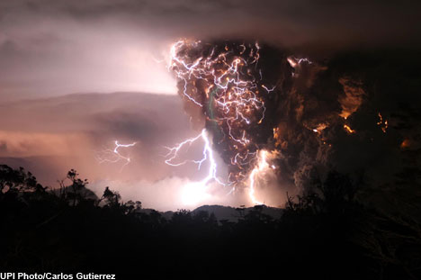
Lightning storm during eruption of Chaiten Volcano, southern Chile.
News Article
After raining out of the atmosphere, life giving organic molecules of many kinds would be washed from land into lakes and streams that flow into the ocean where they concentrate on the shoreline. Wetting and drying cycles would then polymerize (form lengthening chains of) the amino acids into proteins to (when wet) form a plasma similar to what is inside of cells. This plasma would be an ideal incubating environment for the self-assembling cellular components and organelles of living cells.[7] Directional currents would allow cellular components that require a specific environment to be produced in one location then storms wash this off the shoreline to another environment suitable for formation of another type of organelle.
The next best thing to being there to explore the prebiotic environment in an aquarium for molecules that were likely in the ocean at that time. Plan it to be 1/4 to at most 1/2 full. To make best use of the aquarium work area and see any underwater sedimentation, one corner is deep-ocean while opposite corner is the shoreline area made by placing bricks, flat stones or gravel along two sides. Used below is redstone (also called brownstone a type of slate) that has depressions made by small dinosaurs to form the coves where molecules collect. Any material with similar contour and contrasting color can be used.
An aquarium airstone produces the churning water turbulence to in turn produce sea foam along with currents and some wave action. Large storms and hurricanes are simulated by periodically stirring without creating a tidal wave that wipes the beach clean of what was gathering there. Although optional, airstone on end of rigid tube is also a convenient stirrer. Make of length and weight (like glass pipette or stainless tube) where the airstone stays down in corner on its own when hose on other end is rest on top of opposite corner. Organic molecules in the chemical environment are attracted to then collect on the bubble’s gas/liquid interface, with the molecular load being delivered to the surface by the air bubbles.
To the water we add organic molecules. Membrane forming amphiphilic molecules (also produced by hydrothermal vents) are found in soap (use caution not to use too much) and egg yolk. A box of Jell-O gelatin and the egg white (albumen protein) to add amino acids and structural proteins that would have formed where there are amino acid molecules present which through shoreline wetting and drying cycles can form peptide bonds, producing longer protein chains. A small pinch of meat tenderizer (protein enzyme) is a protein catalyst with an active site that cuts other proteins into shorter pieces, to help prevent over-coagulation which is why when pineapple or other substance containing a protein that can do this is added to Jell-O it will not gel. Adding more tenderizer decrease size of protein strands. Or do not add, to encourage formation of growing protein chains. RNA, DNA including cellular organelles can be added by blender liquefaction or chemical extraction from onion, peas or other plant cells.
After a number of hours the airstone can be turned off then a spot cleaned on the side of the glass to look at the model shoreline to see what the "protein skimming" removed from the water, now washed up on the shore. This is a photograph of strawberry-kiwi (pink) flavor Jello and egg white (albumen protein).
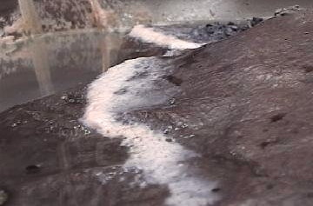
Wherever even the most rudimentary biological living intelligent things are at work the blissful world of fully reacted molecules in a CO2 atmosphere where there is little chemical change becomes a dangerous chemical chaos. The culprit of firestorms and other cataclysm is the presence of Oxygen[8][9][10] from the presence of “life”.[11] At all levels of complexity, living things profoundly change each other in response to each other’s behavior in ways that make it hard to explain the origin of features of one without including features of all living intelligent things around them.

Molecular intelligence of a cell is beyond the control of cellular intelligence that cycles much faster than by replicating then maybe slow differentiation. Cellular intelligence adds to that a level of moment to moment intelligence to control flagella and other appendages. A centrosome adds to whatever cellular intelligence already exists for migration and other animal cell behaviors required for multicellular development. Cellular intelligence that produces our bodily growth is likewise beyond the control of the brain of multicellular intelligence that gives a colony of social cells moment to moment awareness to control multicellular organisms such as ourselves.

An example of molecular intelligence part of a cell are stem cells which have receptors on their cell surface for different morphogenetic (substance that evokes differentiation) proteins. Interaction of the protein with the receptor initiates a cascade of events that eventually turns on some genes and turns off others, causing the differentiation of the cell. Successful actions to take in response to environmental conditions are recalled from genetic memory. New memories are formed as in the classic example of the origin of nylonase[12] where a successful response to environmental conditions is the result of a good guess that leads to a new action to be taken. This is how molecular intelligence learns over time.

Without the circuitry in all the rest of the cell the guess mechanism that found the nylonase solution is protointelligence that can store an action but not use or replicate it into the next cycle of intelligence that exists from one thought cycle to the next thought cycle, through time. Looking at one part of a cell’s intelligence system does not by itself explain what makes the cell intelligent which requires component of time to exist, such that all of the replications of a cell since creation indicates how long it has sustained itself, its age.

Along with its centrosome animal cellular intelligence (protozoans, colony forming stem cells and social amoebas) has an excellent ability to navigate its environment. Observing microscopic single celled hay infusion protozoa shows most rudimentary animal cell intelligence. In the centrosome equipped social amoeba (slime molds) are advanced migration behaviors, extremely adaptable cells required for even the most primitive animal behavior. In the process of each meeting their needs, social cells intuitively work together to form streaming or solid multicellular colonies of various designs.

What ends up grazing in intelligence produced pastures depends on what kind of living thing the intelligent farmers are. At our level, we have our farm plants and animals such as cows and chickens, along with animals physically able to help with farm chores. For single celled social amoebas[13] (slime mould) the livestock they raise is a special kind of bacteria. When unfavorable conditions produce famine, instead of eating them all the farming amoebas save some to store as seed (spores) inside a protective capsule they construct so at least some in the colony survive to reestablish itself again later.[14] Also, the environment bacteria can graze includes the inside of sea creatures, where an impressive self-lighting system is made by coordinated group actions of cultivated bacteria.[15]

Successful designs remain in the biosphere’s interconnected collective (RNA/DNA) memory to help keep going the billions year old cycle of life. We are here the result of a molecular learning process that keeps itself going through time by replicating previous contents of genetic memory along with good (better than random) guesses what may work better in the next replication, children. Resulting cladogram shows a progression of adapting designs evidenced by the fossil record where never once was there not a predecessor of similar design (which can at times lead to entirely new function) present in memory for the descendant design to have come from. Epigenetic systems regulate morphological change within a certain range, which can be used to some degree predict future morphology.

Speciation is generally defined a process that causes enough change in an organism they no longer reproduce with each other anymore, but differing kinds of species can still have offspring that are then called hybrids of varying fertility rate. Oppositely, in farming there are breeds of cattle (colloquially called “cows”) that are not always able to interbreed with each other, yet all domesticated cattle are still classified as the same species called Bos primigenius.

How long it would take a lineage to speciate depends on the learning rate (how fast it gains or changes new information/genes) of that molecular intelligence system. There are "living fossils" that have changed so little it seems to us that they should have become a new species by now. But where a design works, it can stay the way it is.

Living things must have a way to recognize their own kind out of all the other species that exist. One example of when things go wrong is from ranchers who sometimes have a serious problem with a moose that thinks they are a cow, or at least would rather prefer to be one. This identity crisis could be further complicated by loneliness and being safer in a herd with other animals, so that even where they know they are different a lonely moose may still prefer the company of cows. Regardless of their reasons for wanting to remain with them, keeping such a giant easily angered animal out of the herd where they think they belong is not easy. Where left to roam with the cows the moose cannot parent any calves, which helps explain why there are not many moose with such a serious species self-recognition problem. And the cows who know a moose when they see one, will do infinitely better than the cow who pairs up with the moose because it cannot tell the difference either.

In living things this recognition system is guided by sound (crickets), light (fireflies), chemical (bacteria, moths, some mammals), pollen design (plants), and visually where male peacocks use a brilliant tail to attract a female of their species while male bower birds build adorned huts to visually attract a companion. Even where entirely decorative features make it more difficult to fly from predators or may require a large amount of effort to construct a dwelling they still exist as a required part of their species identification system.

The fate of all species are at the mercy of climate change, volcanoes, earthquakes, floods, and other disasters to survive we can to some degree predict where a speciation direction is drifting towards by how it idealizes itself. What the living thing finds aesthetic and desirable may at least in part indicate where the molecular intelligence system that produced it is heading. In the peacock example there must first be males who are born with a more spectacular tail display for there to be any at all that are more impressive over others for females to choose from. More colorful displays are not being produced by what the female finds desirable this is a product of what the peacock’s molecular intelligence system is already producing to enhance its species recognition system. What they in their mind find desirable at the multicellular intelligence level can be emergent from behavior at the molecular intelligence level being expressed through cellular intelligence to the level of the emergent peacock multicellular brain. An expression from their molecular level genome on up to what they perceive in their mind is known to be a chemical response produced by hormones that cause physiological change that attracts them, and us, to our own species.

The human species recognition system is also highly visual. We have words like “apish” or “hideous” to describe the looks and behavior of even our closest living relatives the chimpanzee, bonobo, and other great apes. In our art and culture we find abstractions that exaggerate the real life features that we look for, as a result the size of Betty Boop’s pupil alone is the size of her whole mouth yet we still recognize this cartoon image as being that of an attractive human. In advertising the looks of "sex symbols" are sometimes computer enhanced to represent the ideals not (yet?) common in our morphology. What is added or removed from the picture helps show what human intelligence finds most desirable. We are so visually responsive that just a picture of something we find attractive can produce a hormone based molecular arousal, or as in the common phrase “love at first sight” there is an instant behavioral change that produces an extreme desire to be with someone.

The exaggerated proportions we still find human looking may in part have a neurological cause produced by the way parts of our body with fewer sensory connections to the brain subconsciously appear smaller than lips, hands and other parts that have many sensory connections. A cortical homunculus (Motor Homunculus) is a pictorial representation of the anatomical divisions of the primary motor cortex and the primary somatosensory cortex the portion of the human brain directly responsible for the movement and exchange/addressing of sensory and motor information. The resulting image is a disfigured human with disproportionately huge hands, lips, and face in comparison to the rest of the body. This concept relates to many neuro-biological phenomenon including "phantom limb" and "body integrity identity disorder".

In art, exaggerated proportions can look good as in the excellent example below where even with disproportionate features they are still recognizable as an aesthetically attractive human.



At a more personal self-recognition level we communicate what we identify with (our self-image) using fashion. For colorful display there are bright feathery hats and dresses that can outdo the plumage of a peacock. There are artificial furs to dress us up as an animal of our choice such as leopards, rabbits, as well as leathery skins for the look of an alligator. Uniforms that are all the same conveniently identify police, soldiers and firefighters. And being so self-conscious how we look to others makes wearing nothing an unconfident state of mind, including to others around them. Without clothing fashion there is a loss of identity, as well as loss of protection for our sensitive skin that is designed for heat regulation (by sweating) and does not have a protective coat of fur which makes it more vulnerable to mosquitoes and biting insects. We have the ability to adapt ourselves for a wide range of climates and in the case of firefighters their protective clothing and a self-contained breathing apparatus allows them to walk through flames that other living things could not survive.

Due to systematics being important, what here makes human and ape most different is a relatively major genome restructuring of ancestor genome with humanlike 48 chromosomes that by head to head telomeric fusion of two chromosomes became our second largest #2 chromosome. Chromosome territory and other changes likely made this a somewhat traumatic event for our living genome to recover from. Apes just kept on going with the undisturbed 48 design that is stable making ape relatives but not humans. We are here the result of a new direction being set by our molecular intelligence good guess mechanism of chromosome fusion.

With circuit systematics included there are events that are expected to rapidly produce a new species, such as in human chromosome speciation[16]. There is a relatively sudden genome produced transition, a “speciation event”. Parents that gave birth are here both with 48 chromosomes and the same species that gave birth to chromosome design with a fusion that makes it 47. Chromosomes come in pairs (one from each parent) and work best when identical, leading to 46 becoming established with two fused chromosomes paired up. This is not the same as in crossing different species such as donkey and a horse, where there is the birth of a mule that is normally sterile but on rare occasion are fertile.

Although there was not a significant amount of gene scrambling at the fusion site, even in common much less disruptive fusion events that do not create a new species, the rearranging of the chromosome territories can produce large-scale gene expression changes.[17] The fossil and phylogenetic evidence also indicates our divergence from a common ancestor at the estimated time of this fusion.
The first fused chromosome is in either allele (mother or father) of the haploid (has one of two sets of chromosomes) germ cell (egg or sperm) that divides down to develop into a 47 chromosome heterozygote (alleles are different not homozygous where allele pair each the same). This one copy expresses human chromosome #2 along with copy of the two chromosomes with no fusion that provides all that the cell had before so it is not a sudden unsurvivable change. The new fused chromosome is controllable through epigenetic systems to immediately reregulate genes to a successful balance. We now have the first human Chromosome #2.
Next, the fused chromosome replicates to go from 48-ape, to 47-protohuman, to 46-human, in the population as follows:
48 and 48 parents produce a 48 offspring only.
48 and 47 parents produce a 48 or 47 offspring.
47 and 47 parents produce a 48 or 47 or 46 human offspring.
48 and 46 parents produce a 47 offspring only.
47 and 46 parents produce a 47 or 46 human offspring.
46 and 46 parents produce a 46 human offspring only.
The 47’s were an intermediary transitional stage that soon led to a stable 46 chromosome genome, which requires the fusion present in both gametes, both parents. It is possible this may have produced a noticeable enough of a morphological and/or behavioral change that others in the population noticed different about the 47’s then the 46’s that followed.

It’s here a two-stage chromosome speciation transition that favored 47/47 then 46/46 couples but did not exclude 48/47 or 47/46 from pairing up. Sudden gene expression changes provided a mechanism by which our very earliest ancestors knew they were different and already had the tendency to begin to intelligently reproductively isolate themselves from the population of 48’s from which they were born. New traits that were being expressed may have been seen as sexy or useful in a way that made them popular, with the opposite sex. Who ends up pairing with another is highly intelligence driven and some are attracted to brainy intelligence itself, as opposed to only physical looks. Having a new gene expression that makes one popular is all that is needed for the new genotype to flourish.

With all considered, the human design had a definitive beginning which required a chromosome speciation event to separate our lineage from our 48 chromosome ancestors that were not a chimpanzee they would more specifically qualify as “humanlike”. Where "human" is defined as being the result of this chromosome fusion there is a man and a woman progenitor couple deserving the colloquial name Chromosomal Adam and Eve, who birthed descendants who would prefer to be with their own kind through time, all the way from them to us…

Intelligence System – Theory of Operation

The core model of this theory is an Intelligence Algorithm that models the systems biology interaction required to produce intelligence, with algorithm optimized for digital RAM memory systems of a personal computer. Neural networks are another way to achieve this system interaction, biologically accomplished by molecular intelligence systems that similarly have spatially and chemically addressed genes for data elements. There is here a small fast algorithm/circuit for generating rudimentary intelligence, to control the molecular, cellular and multicellular intelligence of virtual entities.

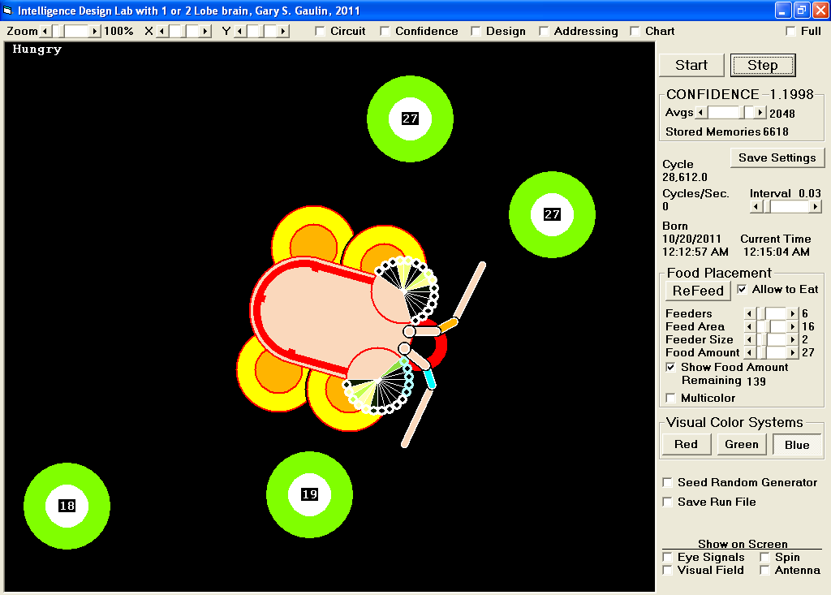

Source code written in Visual Basic 6.0 along with .exe run file that does not install anything that later requires uninstalling is available here:
http://intelligencegenerator.blogspot.com/
https://sites.google.com/site/intelligenceprograms/Home/IntelligenceDesignLab.zip

Large round eyes with a mouth in the middle is a good approximation of overall geometry resulting from flattening of 3D dynamics to a flat-land world with no up/down. This greatly simplifies the modeling task without loss of relevance to real-world biological systems.

Each eye simply senses the brightest lit facet in one or more color subsystems for red, green and blue. In sunlight a honey or bumblebee would detect food by it being bright in ultraviolet blue, here represented by RGB screen color blue that is also present in bright white of food color but not in the green that surrounds it. Including the green or red subsystem in the circuit makes it aware of the green or red features in its environment, otherwise ignores them and is entirely focused on food color.

It is possible to add edge and other detection but here the model does not most need faster response, it first requires simple light detection system to produce the basic signals listed below:

LeftSees and RightSees provides a 1 bit signal that is on (line color changes to red) when the eye sees even a small amount of the system color (red, green or blue) in any facet of the eye.

LeftTowards and RightTowards sensors are 1 when brightest facet is seeing increasing intensity, getting closer.

LeftEye and RightEye are a number from zero to the number of eye facets, counted outward from mouth where the first is number 1, to usually 7, 15 for best use of counting space in a binary memory space. Zero indicates that the eye does not see anything, in which case the LeftSees or RightSees signal is zero. In the program the Eye signal is an array variable where Eye(0) is the left Eye, and Eye(1) is the right Eye.

LeftAntenna and RightAntenna are 3 bit values from 0 to 7 depending on actual travel speed in forward or reverse direction and any sudden turn producing side motion that makes left and right antenna no longer balanced, values not equal in value to each other anymore.

TasteFood is 1 when mouth is on top of food, else 0. It is included so that the navigation subsystems always get a reward boost in confidence for having reached the food, instead of occasionally being penalized when eyes and other navigation sensors go bad when it gets there. This does make it possible to learn how to slow down and sometimes does stop, but the system it’s in is for high-speed travel towards what it sees. Have to expect a sloppy eater, but to it that is just the way it likes to eat. It normally tries all different ways of feeding, instead of just staying with what completely stops the motors in the middle of the food spot. The ideal behavior is already in the mix of things it tries, not missing behaviors. If it were an electronic intelligence then TasteFood can be a battery charger sensor that would go to logic 1 when it makes contact. The TasteFood signal is also a first step to adding a digestive system where it has to swallow, digest, then poop out the indigestible waste.

Correlation is one bit indicator that is 1 when what it sees is getting closer to center of vision between both eyes, or is holding. Correlation is derived by subtraction of left and right eye readings to produce an amount that varies from perfectly correlated 0 to plus/minus number of facets of mismatch between what the two eyes are seeing as brightest. Correlation is 0 when both eyes see nothing.

GoForward and GoReverse are are taken as a two bit binary number where, 00 and 11 are stops that keep same speed, while binary 01 or 10 increasing speed in either forward or reverse direction of its motors.

GoLeft and GoRight are 1 bit and when 1 subtract or add angular amount to travel, electronically accomplished by slowing down motor connected to but not other motor. When both GoLeft and GoRight are a 0 or 1 it still goes straight ahead with no turning. The speed at which it turns can be changed on the "Design" form using the "Turn Angle" scroll that is calibrated in degrees of movement in each time step. When forward/reverse speed is zero, turning results in it spinning in place around its body's center axis.

Its simplified circuit diagram can be displayed by checking “Circuit” showing timing state after having completed a memory cycle, that begins by addressing another memory in one of the lobes and Subsystems that control motors.

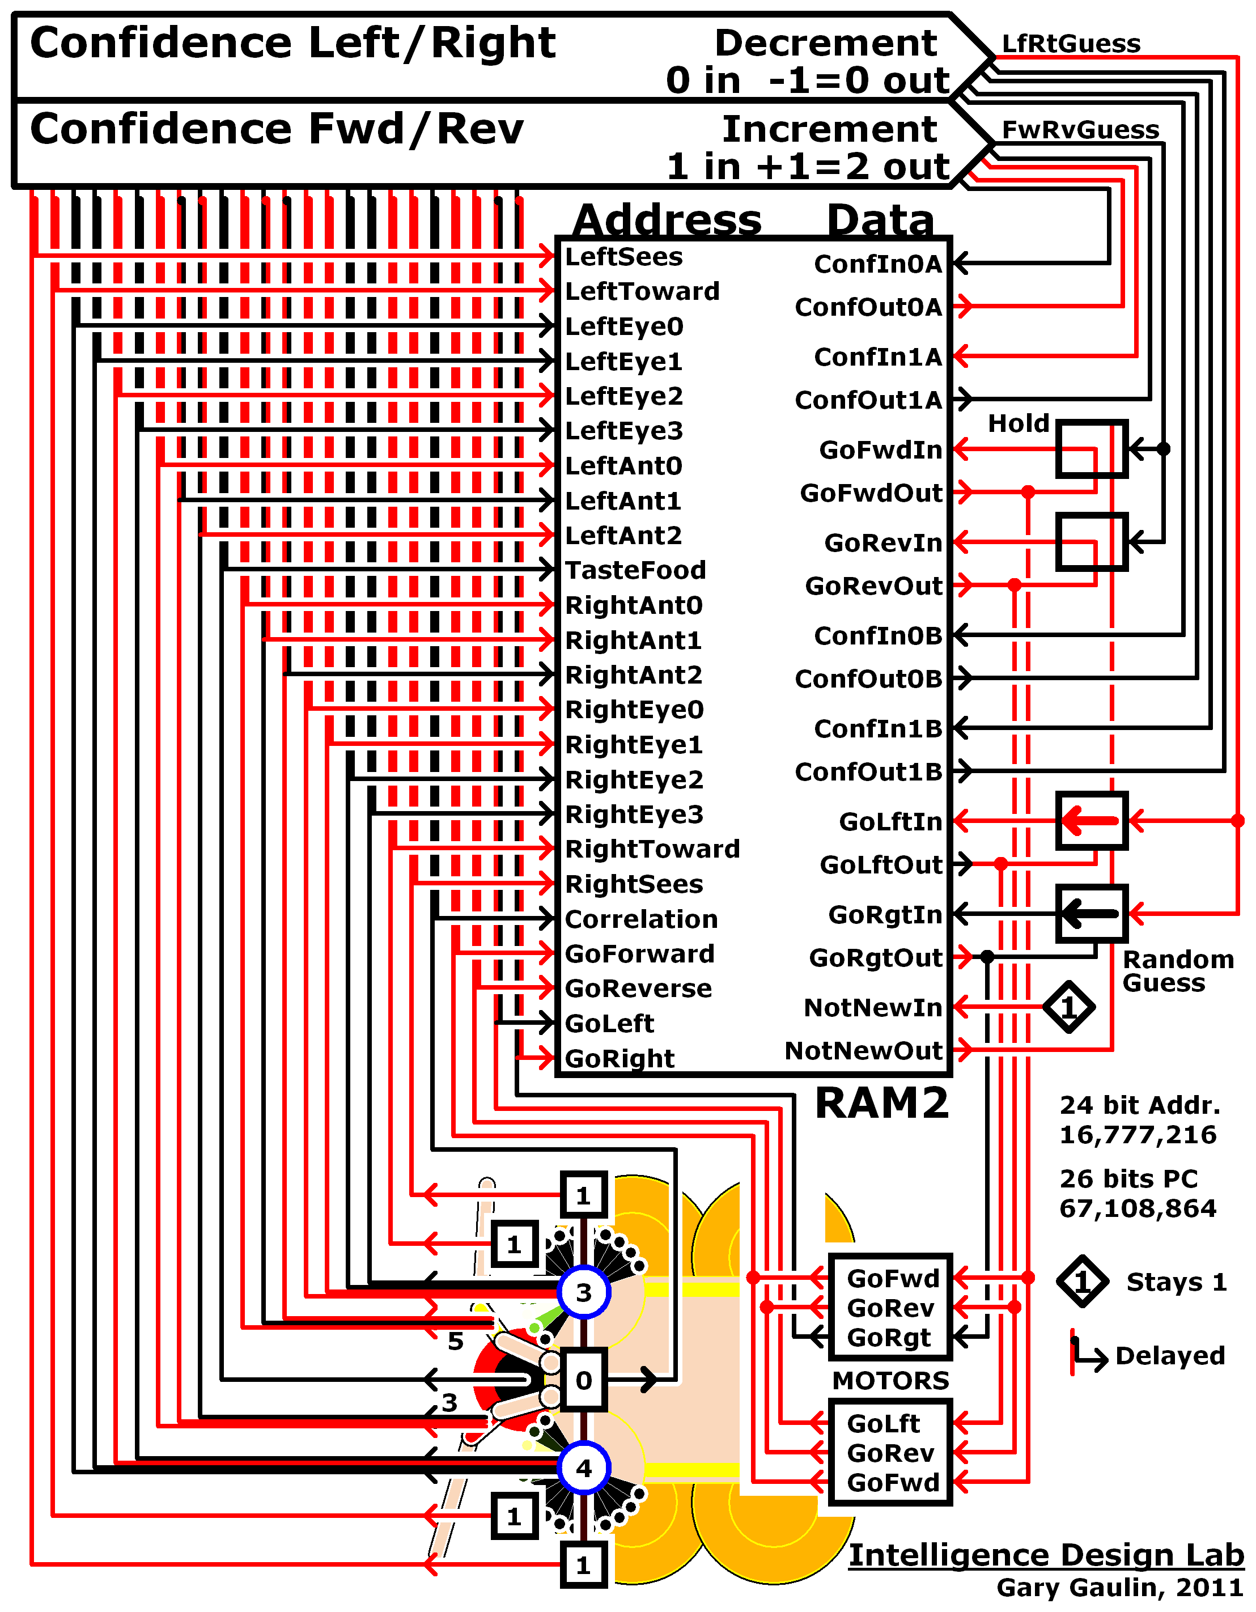

In biology, myelinated motor axons that connect memory to sensors then sensors to the Confidence circuit have a very fast signal transmission rate in comparison to neurons that form the RAM circuit where neuron to neuron propagation delays produce a delay that holds previous data. The Data from memory is then a past set of actions from an earlier moment in time. We have to first try something before knowing how well it works, requiring behavior evaluation to act upon past actions. Faster memory access speed is here not necessarily better.

In an electronic circuit the signal transmission rate of a bus wire is close to the speed of light, and an electronic RAM is way too fast for the circuit. Proper timing would here require delays that holds the addressing bits for one memory chip read/write cycle so that it is acting upon a previous moment in time. For electronics is a second way to draw the circuit better show where delays must be added.

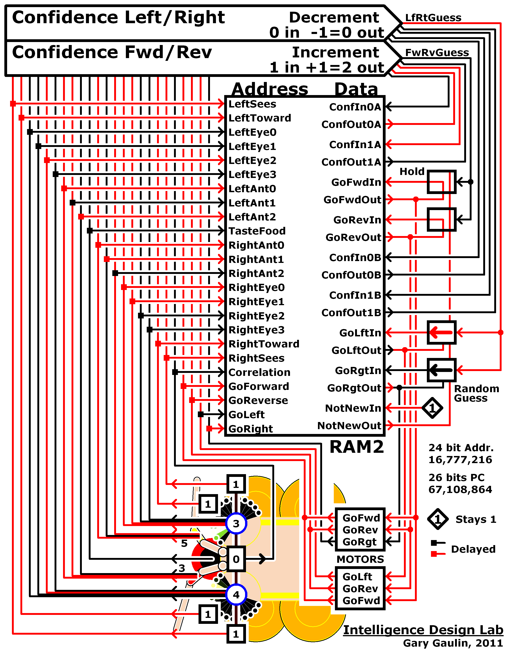

The drive motor design is based on insect/animal view of navigation vectors where there is a controllable Forward/Reverse speed and a controllable Left/Right turning torque to apply for change in angular travel direction. Motors here have 8 settings numbered from 0 to 7 that represent: Rev-3, Rev-2, Rev-1, Stop-0, Fwd-1, Fwd-2, Fwd-3, Fwd-4. Actual travel speed and direction is sensed by antenna, with the intelligence only controlling shifting from one speed to the next and to turn, using four motor data bits for forward, reverse, left and right. Maximum travel speed and amount of turn can be changed on the Design form using the Speed and Turn Angle scroll bars. Color code is used for wheel/wings which are Red when stopped then in either direction goes from Yellow, to Green, to Cyan, to White. Innermost wheel color what speed was, outer is current speed. Confidence is shown with traffic light colors then white: 0=Red, 1=Yellow, 2=Green, 3=White. Indicator circle (behind eye) and stripe along side shows Confidence level.

On the left side of RAM there are sensors connected to Address Inputs, addressing its Data bits on the right of the RAM. As in our muscles where there is a feedback neuron back to the brain, the motors of this circuit send feedback to address inputs of RAM memory, which makes the intelligence system aware of what its motors are doing.

The number of address bits/pins/inputs is related to the number of memory locations in the RAM, and how many address bits are needed depends on how many sensor bits there are in total that need to be connected to it. Bits that will never change in value are a waste of memory space to include, but for example when only the blue color subsystem remains selected the two “System” bits will remain binary 10 to keep subsystem 2 (blue) addressed. In this case even though the two “System” bits might not often change, this allows other subsystems to later be clicked into addressing by checking its checkbox.

Regardless of the order in which sensors are connected the circuit works the same, but once started must not be completely changed. In a biological circuit it is possible to take a guess by transposition which moves a data element to another memory address, but that is a small one data element at a time address change happening inside the RAM, with what is stored there.

Although some RAM chips multiplex the same connection pins for more than one purpose, other than proper interfacing being included, the circuit simply connecting sensors to the address inputs of a RAM memory system requires no memory management system as in a PC. Sensors only need to be directly connected to address inputs, to address one of the RAM data locations at a time. In a biological memory system data elements can include genes where two or more may have the same physical and chemical address, but the simple concept is the same: What is sensed by sensors addresses corresponding data elements that store appropriate action (or actions) to be taken in response.

Thicker analog lines shown in the schematic such as from center of eye, are like biological neurons that generate analog signals by varying their firing/pulse rate, how fast the neuron is firing determines the magnitude of its signal. There is then more than two states (on and off) coded in their firing rate and pattern. A single wire/line then replaces what would otherwise require two or more connections, where biologically there only need be one. The two bit confidence values can also be coded to use a single connection to an analog RAM, but is here for simplicity showing the binary RAM that the algorithm is working from.

The "Confidence Forward/Reverse" and "Confidence Left/Right" circuits monitor environmental conditions being sensed by all sensors connected to memory Address inputs, although not all are being internally used. In the source code their inner circuitry uses If...Then... statements to gauge success that in an electronic design can be formed with a logic gate circuit (not shown) made of AND, OR, and NOT gates. They each also have a confidence level that works off of two memory data bits, for a level that ranges from 0 to 3 where 3 is highest confidence, 0 is a new memory or needs a guess taken.

The program has a “Confidence” checkbox that sums up what the truth table looks like while being added to by that set of input conditions being encountered. The table does not show exceptions, is there to give the general idea of how the two pointy Confidence blocks work inside, that reduces to a truth table as shown below:

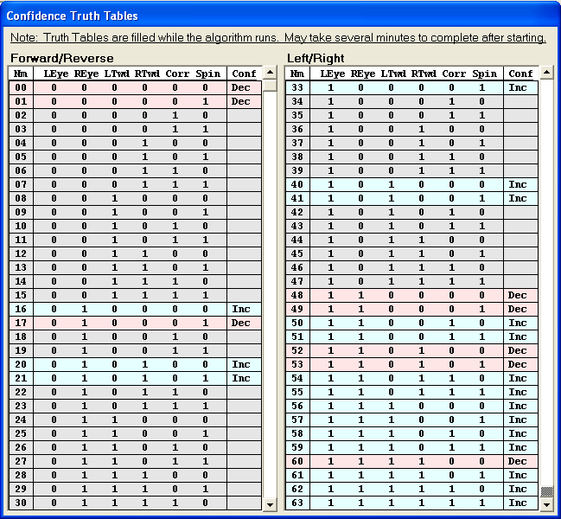

From the point of the tip is a 3 state connection to their respective guess control, turning noticeably blue when a good guess is allowed. The math equation and whether confidence was incremented or decremented is shown in the lower right of schematic confidence block, the word “in” indicates confidence value that came in from memory data, and “out” indicating that is the new value sent out to be stored at that memory data address. Because of the highest number allowed being 3 the equation will sometimes be 3+1=3 even though normally it would be 3+1=4 and for a decrement it cannot go below zero resulting in 0-1=0 even though normally it would be 0-1=-1. Keeping the confidence within range of 0 to 3 results in this math being shown.

On the Data (right) side of the RAM, Hebbian learning type Data In/Out feedback normally holds last state of its data bit when addressed, as shown below.

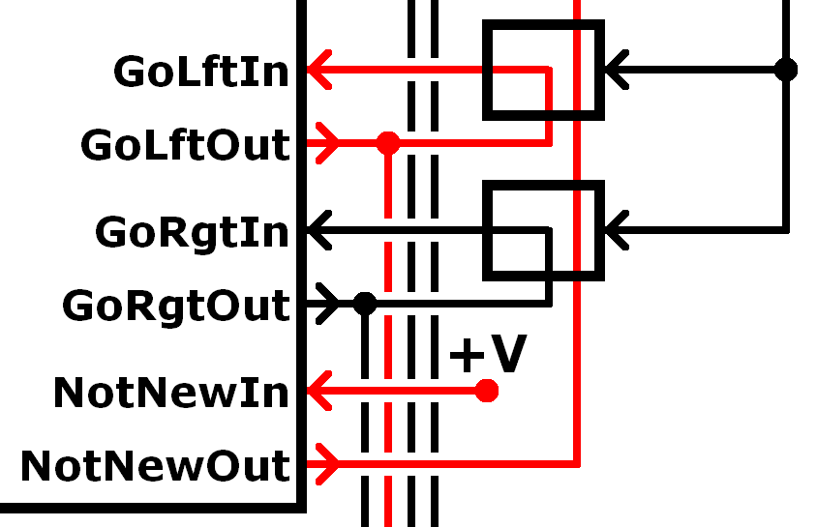

NotNewOut bit powers a gate that must be 0 (black) for a good guess, that keeps the same working motor settings. NotNewIn always getting +V volts becomes a 1 after first time being accessed. Instead of a data bit just for new memory detection it is possible to detect whether the data is zero or nonzero, which works as long as data is always nonzero, which here does not matter. Memory confidence levels are allowed to go back to count of zero. Next time accessed the zero is detected to produce guess that was taken in the first half of the cycle, that is on the second half of the algorithm cycle tried, then confidence in that action gauged

Good guess keeps the same working motor states. Confidence must allow (line is blue) and NotNewOut be 0 as shown below:

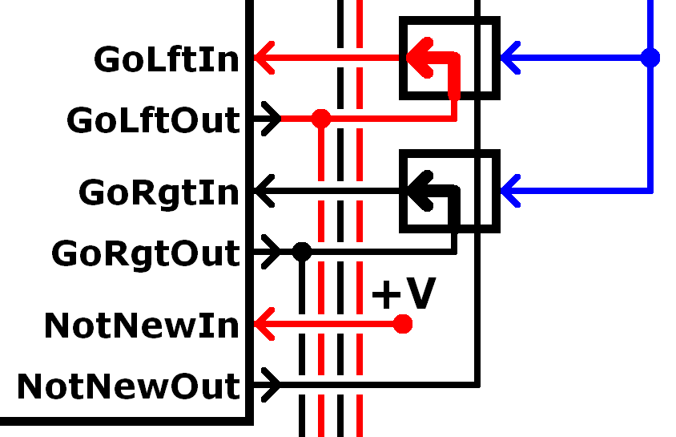

Random guess ignores Data Out and NotNew, directly sets random value to Data In and motors. Shown below the NotNew gate is instead here a 1 indicating that it is not a new memory in which case there is no good guess taken it is instead random guess:

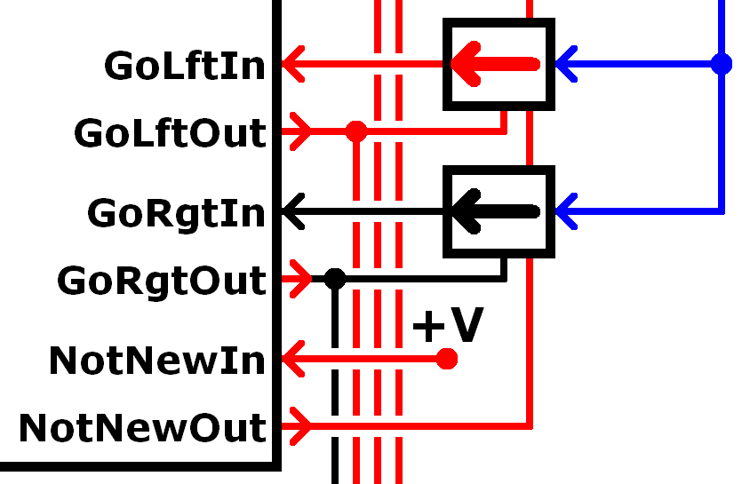

When the line from Confidence is a 1 (red) it is always a random guess that is taken, as shown below where gate is 0 which would otherwise allow a good guess:

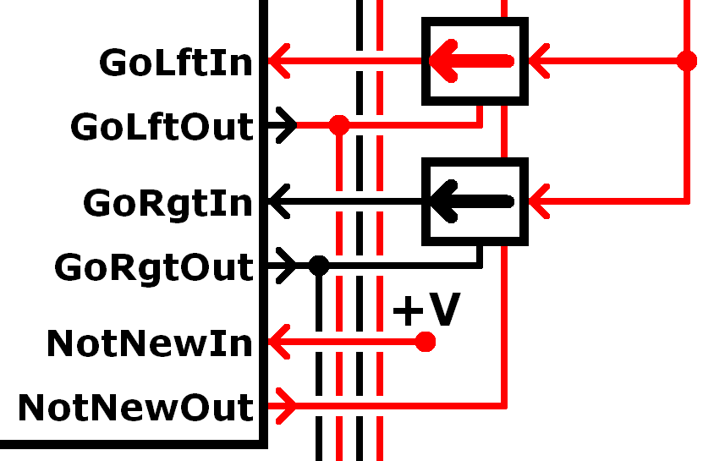

Electronically, a random guess can be provided by amplified zener diode noise that fast varies from 0 to 1 being saved to Data Inputs at start of cycle. The state the bits at the moment they were written to RAM as new bits will determine their final values.

The above method of controlling a guess helps compensate for how a digital RAM starts off with all data locations in the memory set to zero and needing to be one at a time loaded with data. Output neurons used as data elements would not suddenly become value of 0 for slight changes in addressing, normally stays with what was working. While we are walking we do not stop to take a guess every single time we see something that we have never seen before. Our good guess system keeps us moving along as we were, unless there is something in our path that requires us to take a guess how to safely get past an obstacle. Adds some of the properties of a more communicative neural network, to an algorithm optimized for binary RAM as in personal computer or chip.

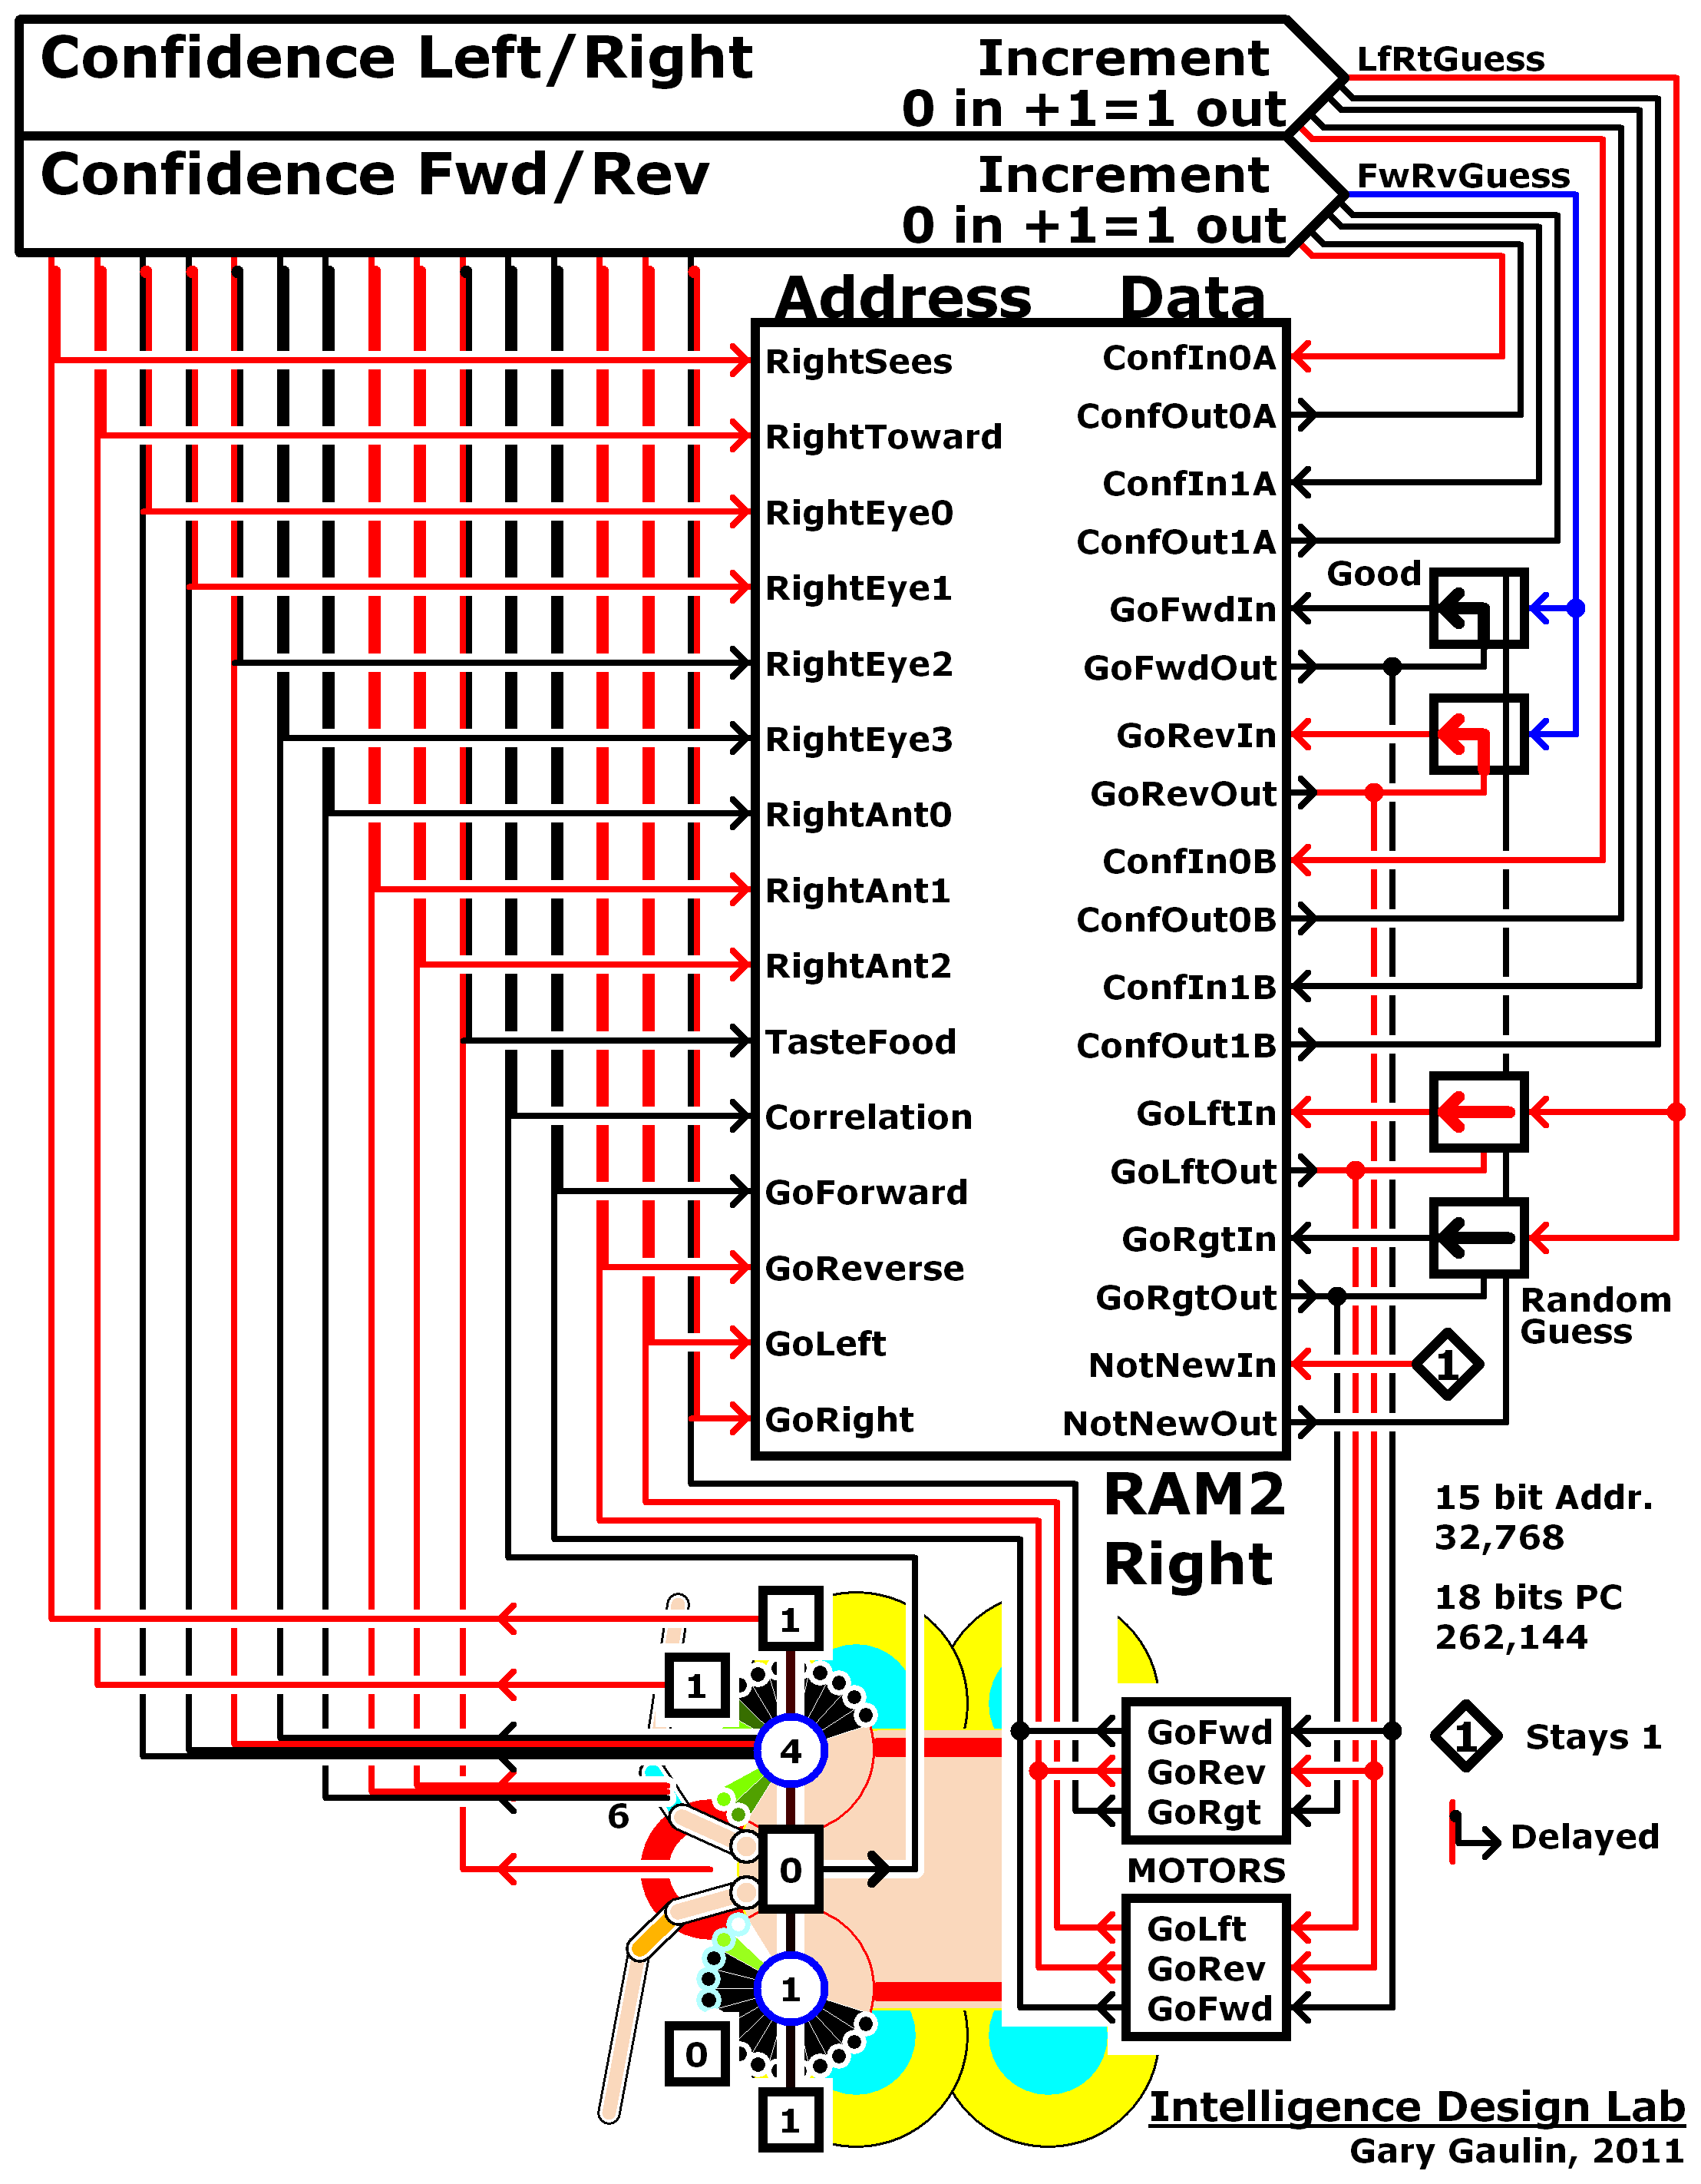

Unconnected arrows pointing to the left are for left side of brain, where there is another circuit like this for that lobe. All circuits are connected at motors by their in-turn control of the same motor settings and receiving motor feedback back to addressing side of the circuit. This is the simplest way to combine lobes and systems. Although efficient, this method can on rare occasion lead to its version of obsessive compulsive disorder where it gets stuck in one place repeating the same successful actions over again. Its confidence can then soar to a euphoric 3.0000 which is more like finding a way to beat the system than it is a problem, but like turning a light switch on and off for an hour nothing else gets accomplished. In the real world there would be less chance of that happening especially when hunger sets in but in this virtual world where the terrain is perfectly flat and motions perfectly uniform and starvation is not an issue the mathematically generated entity can stay in one place forever. If it should get stuck in repetitive actions then pressing the “ReFeed” button will move things around in the environment which will get it back to other things.

Dividing up the sensory load for each bilateral side between two lobes can greatly reduce the addressing space required to control bilateral symmetry. When modeled with same design parameters as the earlier schematic memory requirements go from 16,777,216 locations, to two lobes with 32,768 locations each. There is only slight loss of performance in part from model now only addressing one side per program cycle, instead of both bilateral sides responding in each cycle. This may help explain why bilateral symmetry with two lobe brains is so common. Not only are the addressing requirements much lower, it then possible to form cross-talk connections (here not included) between the two halves to communicate back and forth with each other.

Intelligence Algorithm

The RAM of the intelligence algorithm is a 16 bit (9 used) integer associative memory array appropriately called “RAM()” that is addressed with variable “Addr” to recall data bits, into “DataOut” variable that is read with “DataOut = RAM(Addr)”.

The “Call FormUniqueMemoryADDRESS” causes the program to jump to a subroutine that combines the readings of all sensors into a unique number in variable “Addr” that is then used to address RAM to recall memory associated with it into DataOut variable.

Private Sub IntelligenceAlgorithm()
Call FormUniqueMemoryADDRESS 'Combine sensor bits for new Address.
DataOut = RAM(Addr(S)) 'Read RAM data into DataOut variable.

After reading data into DataOut its two least significant bits (3=00000011 binary) are read into Forward/Reverse Confidence variable “FwRvCfIn” that in the schematic diagram are the two bus lines coming in on the lower right of its pointed Confidence circuit from their respective outputs from RAM data bits. The next line of code “If FwRvCfIn = 0 Then” detects that a guess needs to be taken by confidence being read in from RAM is zero. If it is not a 0 the program skips to the “Else” that instead loads motors from RAM data outputs. When confidence is 0 the “If DataOut > 0 Or FwRvAdj = -1 Then” detects whether it needs a random guess be taken. The “Rnd” variable is a random generator that is a fractional amount number from 0 to .9999999 that never goes all the way to 1. Adding 0.5 makes the random number above or below 1, with “Fix()” applied to remove fractional amount so its an integer either 0 or 1. If it is not a random guess then it takes a good guess, by doing nothing at all. Whatever the motors were set to remains the same.

FwRvCfIn = (DataOut And 3) '2 bit Forward/Reverse Confidence.
If FwRvCfIn = 0 Then 'If Forward/Reverse Conf=0 THEN Guess.
If DataOut > 0 Or FwRvAdj = -1 Then 'If Motors OK GoodGuess = keep same.
GoFwd = Fix(Rnd + 0.5) 'One bit Random Guess, 0 or 1=Fwd.
GoRev = Fix(Rnd + 0.5) 'One bit Random Guess, 0 or 1=Rev.
End If 'Since Fwd=1 or Rev=1 NonZero Data.
Else 'Else load memory bits to motor latch.
GoFwd = (DataOut And 4) / 4 'Get Motor Forward bit from RAM.
GoRev = (DataOut And 8) / 8 'Get Motor Reverse bit from RAM.
End If

The same as above is applied to Left/Right motor bits, to either guess new action or use action recalled by addressing RAM.

LfRtCfIn = (DataOut And 48) / 16 '2 bit Left/Right Confidence.
If LfRtCfIn = 0 Then 'If Left/Right Confidence=0 THEN Guess.
If DataOut > 0 Or LfRtAdj = -1 Then 'If Motors OK GoodGuess = keep same.
GoLft = Fix(Rnd + 0.5) 'One bit Random Guess, 0 or 1=Left.
GoRgt = Fix(Rnd + 0.5) 'One bit Random Guess, 0 or 1=Right.
End If
Else 'Else load memory bits to motor latch.
GoLft = (DataOut And 64) / 64 'Get Motor Go Left bit from RAM.
GoRgt = (DataOut And 128) / 128 'Get Motor Go Right bit from RAM.
End If

With the motor bits set the “RunMotorsTimeStep” subroutine runs motors for one time step, to a new location.

'___________ ACT ON MEMORY OR GUESSED MOTOR ACTIONS (ALWAYS INTENTIONAL) ___________
Call RunMotorsTimeStep 'Move one (as in physics) Time Step to new Angle,X,Y
' _________ INCREMENT OR DECREMENT CONFIDENCE BY SETTING ADJUSTMENT 1 OR -1 _________
Call GaugeMotorConfidence

If truth table logic (in code represented by “If..Then.. statements) indicates conditions are OK then motor confidence In is incremented or decrement by one by adding the “FwRvAdj” or “LfRtAdj” amount (+1 or –1) to become the Out bits. Both confidence values must be kept within the range of 0 to 3.

FwRvCfOut = FwRvCfIn + FwRvAdj
If FwRvCfOut < 0 Then FwRvCfOut = 0 'Do not allow Conf less than 0
If FwRvCfOut > 3 Then FwRvCfOut = 3 'Do not allow Conf greater than 3
LfRtCfOut = LfRtCfIn + LfRtAdj
If LfRtCfOut < 0 Then LfRtCfOut = 0 'Do not allow Conf less than 0
If LfRtCfOut > 3 Then LfRtCfOut = 3 'Do not allow Conf greater than 3

In the final step, settings of all Data In bits are written to RAM for later recall.

'_______ SAVE DATA TO MEMORY LOCATION AT ADDRESS OF LAST MOTOR ACTIONS TRIED _______
DataIn = 256 + GoRgt*128 + GoLft*64 + LfRtCfOut*16 + GoRev*8 + GoFwd*4 + FwRvCfOut
RAM(Addr(S)) = DataIn 'Write new Data to RAM.
End Sub 'Will now return to "CycleTimer_Timer()" again and draw to screen there.

The subroutine reaches the End, to return to the cycle timer subroutine it was called from where screen may be drawn then this algorithm is not called again until remaining time duration of the this Interval has elapsed. On the screen Interval timer scroll bar allows setting rate at which algorithm cycles, so that on screen movements can be slowed down, to better see. A Tubo setting skips drawing to the screen that takes much of the computer time, to cycle/age much faster than where redrawing each small step.

Checking “Save Run File” allows saving of Address and Data bits that go to and from memory, while it is running. Uncheck when finished saving. Number of bytes will be shown to the right of checkbox, and automatically turns off the save after reaching the maximum allowed file length of 1 megabyte. File is saved to "Run" folder. Do not use Turbo mode while saving. To begin recording from the very first cycle of its lifetime check the “Save Run File” checkbox then click the “Save” command, then restart program. Be sure to later uncheck then Save again or else it will store a new file every time restarted.

The header of the file lists number of lobes, followed by number of data bits. Number of RAM Address bits is next shown, first for how much memory is used for the entire brain (includes two System bits and two lobe configuration adds one more bit for lobes) followed by how many address bits are used for each color system. The date and start time are also listed, with the finish time added to the end. As shown below for the two lobe configuration, the first bit switches the lobe number from 0 to 1, while switching the color subsystem number to the next.

------------------------------------------------------------------
Compound Eye Intelligence Design Lab.
By Gary S. Gaulin, 2011.
------------------------------------------------------------------
Lobes : 2
Data : 9 bits, 2 bytes per data location
Address : 18 total addressing bits, 262,144 data locations
: 15 subsystem addressing bits, 32,768 data locations
Date : 10/21/11
Time : 11:46:36 PM
------------------------------|---------------
ADDRESS | DATA
------------------------------|---------------
| L F
| / M M /
| R o o R
C | M M t t
L o | o o C o o C
e T r G G | t t o r r o
L f a r o o | o o n n
e t L L s e F R G | r r f F R f
S f T e e t l o e G o | i o e i
y t o f f e a r v o R | R d r v d
L s S w t t F t w e L i | L i e w e e
o t e a E A o i a r e g | e g n a r n
b e e r y n o o r s f h | f h c r s c
e m s d e t d n d e t t | t t e d e e
----------------------------------------------
0 00 0 0 0000 011 0 0 0 1 0 1 - 0 1 11 1 1 00
1 00 0 0 0000 001 0 0 1 1 0 1 - 0 1 01 1 1 01
0 01 0 0 0000 011 0 0 1 1 0 1 - 0 1 01 1 1 01
1 01 1 1 1111 001 0 0 1 1 0 1 - 0 1 01 1 1 01
0 10 0 0 0000 011 0 0 1 1 0 1 - 0 1 10 1 1 10
1 10 1 1 1111 001 0 0 1 1 0 1 - 0 1 10 1 1 10
0 00 0 0 0000 011 0 0 1 1 0 1 - 0 1 11 1 1 11
1 00 1 1 1111 001 0 0 1 1 0 1 - 0 1 11 1 1 11
0 01 0 0 0000 011 0 0 1 1 0 1 - 0 1 11 1 1 11
1 01 1 1 1110 001 0 0 1 1 0 1 - 0 1 01 1 1 01
0 10 0 0 0000 011 0 0 1 1 0 1 - 0 1 11 1 1 11
1 10 1 1 1101 001 0 0 1 1 0 1 - 0 1 01 1 1 01
. . .
0 00 0 1 1111 100 0 0 1 1 1 0 - 1 0 11 0 1 11
1 00 0 0 0000 101 0 0 0 1 1 0 - 1 0 11 0 0 01
0 01 1 1 1111 011 0 0 0 0 1 0 - 1 0 11 0 0 11
1 01 0 0 0000 101 0 0 0 0 1 0 - 1 0 11 1 0 01
------------------------------------------------------------------
Time: 12:03:24 AM
------------------------------------------------------------------

The one lobe configuration below has no lobe bit, only the subsystems need to be changed.

------------------------------------------------------------------
Compound Eye Intelligence Design Lab.
By Gary S. Gaulin, 2011.
------------------------------------------------------------------
Lobes : 1
Data : 9 bits, 2 bytes per data location
Address : 26 total addressing bits, 67,108,864 data locations
: 24 subsystem addressing bits, 16,777,216 data locations
Date : 10/22/11
Time : 03:03:26 AM
-----------------------------------------|---------------
ADDRESS | DATA
-----------------------------------------|---------------
| L F
| / M M /
| R o o R
R C | M M t t
L i o | o o C o o C
e T g R r G G | t t o r r o
L f a R R h i r o o | o o n n
e t L L s i i t g e F R G | r r f F R f
S f T e e t g g T h l o e G o | i o e i
y t o f f e h h o t a r v o R | R d r v d
s S w t t F t t w S t w e L i | L i e w e e
t e a E A o A E a e i a r e g | e g n a r n
e e r y n o n y r e o r s f h | f h c r s c
m s d e t d t e d s n d e t t | t t e d e e
---------------------------------------------------------
00 1 1 0011 111 0 111 0100 1 1 1 1 0 0 0 - 1 0 00 1 0 01
01 1 1 0011 110 0 111 0101 1 1 1 1 0 1 0 - 1 1 00 1 0 01
10 1 1 0011 111 0 111 0101 1 1 0 1 0 1 1 - 0 0 00 1 0 01
00 1 1 0011 111 0 111 0101 1 1 0 1 0 0 0 - 0 0 00 1 0 01
01 1 1 0011 111 0 111 0101 1 1 0 1 0 0 0 - 1 0 00 1 0 10
10 1 1 0010 110 0 111 0101 1 1 0 1 0 1 0 - 0 0 00 1 0 01
00 1 1 0010 111 0 111 0101 1 1 0 1 0 0 0 - 1 1 00 1 0 01
. . .
00 1 1 0110 011 0 101 0010 1 1 1 1 1 1 0 - 1 0 10 0 0 00
01 1 1 0110 011 0 101 0010 1 1 1 0 0 1 0 - 1 0 01 0 1 00
10 1 0 0101 010 0 100 0010 1 1 1 0 1 1 0 - 1 0 10 0 0 00
00 1 0 0101 010 0 100 0010 1 1 1 0 0 1 0 - 1 0 01 1 1 00
------------------------------------------------------------------
Time: 03:07:48 AM
------------------------------------------------------------------

By checking “Chart” a line chart appears on the screen indicating confidence levels, amount of food in stomach, and total number of memories that does not ever go to full scale because of not all addresses being used especially for antenna where both are always almost equal to each other.

Restoring Default Settings
After saving settings for any of the forms that allow it a folder named “Settings” is created where they are stored. To restore settings back to the way they were, delete the folder named “Settings” or the appropriate text file for the Intelligence, Addressing, or Design form.

Acknowledgments

All who gave this theory a constructive informal peer-review are greatly appreciated.

The title and premise that begins the theory "The theory of intelligent design holds that certain features of the universe and of living things are best explained by an intelligent cause" are from the Discovery Institute and can be found in the "Questions about." section here:
http://www.discovery.org/csc/topQuestions.php

The Intelligence Generator/Detector computer model is based on “Evolutionary Adaptive Machine Intelligence” and the book: Heiserman, D. L., How to Build Your Own Self-Programming Robot, Blue Ridge Summit, PA, TAB Books, Inc., 1979. The following is useful information concerning the robotic intelligence system here named "Rodney".
- ALPHA CLASS
While Alpha Rodney does exhibit some interesting behavioral characteristics, one really has to stretch the definition of intelligence to make it fit an Alpha-Class machine. The Intelligence is there, of course, but it operates on such a primitive level that little of significance comes from it. ....the essence of an Alpha-Class machine is its purely reflexive and, for the most part, random behavior. Alpha Rodney will behave much as a little one-cell creature that struggles to survive in its drop-of-water world. The machine will blunder around the room, working its way out of menacing tight spots, and hoping to stumble, quite accidentally, into the battery charger.
In summary, an Alpha-Class machine is highly adaptive to changes in its environment. It displays a rather flat and low learning curve, but there is virtually no change in the curve when the environment is altered.
(2) BETA CLASS
A Beta-Class machine uses the Alpha-Class mechanisms, but extends them to include some memory - memory of responses that worked successfully in the past.
The main-memory system is something quite different from the program memory you have been using. The program memory is the storage place for Rodney’s basic operating programs-programs that are somewhat analogous to intuition or the subconscious in higher-level animals. The main memory is the seat of Rodney’s knowledge and, in the case of Beta-Class machines, this means knowledge that is grained only by direct experience with the environment. A Beta-Class machine still relies on Alpha-like random responses in the early going but after experiencing some life and problem solving, knowledge in the main memory becomes dominant over the more primitive Alpha-Class reflex actions.
A Beta-Class machine demonstrates a rising learning curve that eventually passes the scoring level of the best Alpha-Class machine. If the environment is static, the score eventually rises toward perfection. Change the environment, however, and a Beta-Class machine suffers for a while, the learning curve drops down to the chance level. However, the learning curve gradually rises toward perfection as the Beta-Class machine establishes a new pattern of behavior. Its adaptive process requires some time and experience to show itself, but the end result is a more efficient machine.
(3) GAMMA CLASS
A Gamma-Class robot includes the reflex and memory features of the two lower-order machines, but it also has the ability to generalize whatever it learns through direct experience. Once a Gamma-Class robot meets and solves a particular problem, it not only remembers the solution, but generalizes that solution into a variety of similar situations not yet encountered. Such a robot need not encounter every possible situation before discovering what it is suppose to do; rather, it generalizes its first-hand responses, thereby making it possible to deal with the unexpected elements of its life more effectively.
A Gamma-Class machine is less upset by changes and recovers faster than the Beta-Class mechanism. This is due to its ability to anticipate changes.

References
[1]An overview of E. coli chemotaxis, Parkinson Lab, Department Of Biology – University Of Utah
http://chemotaxis.biology.utah.edu/Parkinson_Lab/projects/ecolichemotaxis/ecolichemotaxis.html

[2] Peter A. Spiro, John S. Parkinson, and Hans G. Othmer; A model of excitation and adaptation in bacterial chemotaxis
PNAS 1997 94 (14) 7263-7268
http://www.pnas.org/content/94/14/7263

[3] Tatiana Y. Besschetnova, David J. Montefusco, Abdalin E. Asinas, Anthony L. Shrout, Frances M. Antommattei, and Robert M. Weis; Receptor density balances signal stimulation and attenuation in membrane-assembled complexes of bacterial chemotaxis signaling proteins
PNAS 2008 105 (34) 12289-12294; published ahead of print August 18, 2008, doi:10.1073/pnas.0802868105
http://www.pnas.org/content/105/34/12289

[4] G. Gaulin, Demonstrating the Self-Assembly of the Cell Membrane, NSTA -The Science teacher, 10/1/2007
http://www.nsta.org/store/product_detail.aspx?id=10.2505/4/tst07_074_07_72
Prior version, open access:
http://www.lessonplanspage.com/ScienceSelfAssemblyOfRealCellMembranesOriginOfLifeExperiment68.htm
[5] FROM: Driving Parts of Krebs Cycle in Reverse through Mineral Photochemistry
Xiang V. Zhang and, Scot T. Martin
Journal of the American Chemical Society 2006 128 (50), 16032-16033
http://www.seas.harvard.edu/environmental-chemistry/publications/XZ_JACS_2006.pdf
http://pubs.acs.org/cgi-bin/sample.cgi/jacsat/asap/pdf/ja066103k.pdf
http://www.seas.harvard.edu/environmental-chemistry/
[6] Johnson et al., The Miller Volcanic Spark Discharge Experiment, NASA, Science 17 October 2008: 404, DOI: 10.1126/science.1161527
http://astrobiology.gsfc.nasa.gov/analytical/PDF/Johnsonetal2008.pdf
http://www.sciencemag.org/cgi/content/full/322/5900/404/DC1

[7] University of California - Merced (2011, August 9). Study builds on plausible scenario for origin of life on Earth. ScienceDaily. Retrieved November 21, 2011, from
http://www.sciencedaily.com/releases/2011/08/110809144517.htm

[8] Berner, RA (Sep 1999). "Atmospheric oxygen over Phanerozoic time" (Free full text). Proceedings of the National Academy of Sciences of the United States of America 96 (20): 10955–7. doi:10.1073/pnas.96.20.10955
http://www.pnas.org/content/96/20/10955.long

[9] Heinrich D Holland, The oxygenation of the atmosphere and oceans, Phil. Trans. R. Soc. B June 29, 2006 361:903-915; doi:10.1098/rstb.2006.1838
http://rstb.royalsocietypublishing.org/content/361/1470/903.full
http://en.wikipedia.org/wiki/File:Oxygenation-atm.svg

[10] Robert A. Berner and Donald E. Canfield
A new model for atmospheric oxygen over Phanerozoic time (in Geochemical cycles, Berner,)
American Journal of Science (April 1989), 289(4):333-361
http://www.pnas.org/cgi/ijlink?linkType=ABST&journalCode=ajs&resid=289/4/333
[11] Johan H Koeslag, "Medical Physiology :: What is Life?", Stellenbosch University, South Africa
http://sun025.sun.ac.za/portal/page/portal/Health_Sciences/English/Departments/Biomedical_Sciences/MEDICAL_PHYSIOLOGY/Essays/What_is_life

[12] S Ohno, Birth of a unique enzyme from an alternative reading frame of the preexisted, internally repetitious coding sequence.
Proc. Natl Acad. Sci. USA 81:2421-2425, 1984.
http://www.pubmedcentral.nih.gov/articlerender.fcgi?artid=345072
http://www.pubmedcentral.nih.gov/picrender.fcgi?artid=345072&action=stream&blobtype=pdf

[13]Colin Barras, Smart amoebas reveal origins of primitive intelligence, New Scientist, 16:11 29 October 2008
http://www.newscientist.com/article/dn15068
[14] Slime moulds bet the farm on survival - life - 19 January 2011 - New Scientist
http://www.newscientist.com/article/mg20927962.900-slime-moulds-bet-the-farm-on-survival.html?DCMP=OTC-rss&nsref=environment
Primitive agriculture in a social amoeba, Debra A. Brock, Tracy E. Douglas, David C. Queller & Joan E. Strassmann
Nature, Volume: 469, Pages: 393–396, 20 January 2011, doi:10.1038/nature09668
Closed Access - Abstract
http://www.nature.com/nature/journal/v469/n7330/full/nature09668.html

[15] Bonnie Bassler on how bacteria talk, Video on TED
http://www.ted.com/talks/bonnie_bassler_on_how_bacteria_communicate.html

[16] Francisco J. Ayala and Mario Coluzzi
Colloquium Paper: Systematics and the Origin of Species: Chromosome speciation: Humans, Drosophila, and mosquitoes
PNAS 2005 102:6535-6542; published online before print April 25, 2005, doi:10.1073/pnas.0501847102
http://www.pnas.org/content/102/suppl.1/6535.full

[17] Harewood Louise, Schuetz Frederic, Boyle Shelagh, et al., The effect of translocation-induced nuclear reorganization on gene expression, Genome Research, Volume: 20, Issue: 5, Pages: 554-564, DOI: 10.1101/gr.103622.109, May 2010
http://genome.cshlp.org/content/20/5/554.full

Further Reading and Resources

G. Gaulin, Intelligence Generator/Detector.
http://intelligencegenerator.blogspot.com/
7 sensors (Stall, Full, Forward, See/Smell Food, Towards Food, Spin Towards, Angle) plus 4 motor bits as "feedback" so memory (brain) knows what the motors are doing.
http://www.planet-source-code.com/vb/scripts/ShowCode.asp?txtCodeId=71381&lngWId=1
If you do not have a Visual Basic compiler then this version is the same as Planet SourceCode but with additional comment in IntelligenceGenerator5.FRM file (the "source code") to help non-programmers and Windows runnable program. Properties (right click) of the IntelligenceGenerator5.EXE program that should match what you received are; Modified: November 14, 2008, 8:24:42 AM Size: 108 KB (110,592 bytes)
http://sites.google.com/site/intelligenceprograms/Home/IntelligenceGenerator5.zip
Guenter Albrecht-Buehler, Robert Laughlin Rea, "Cell Intelligence", Northwestern University Medical School, Chicago.
http://www.basic.northwestern.edu/g-buehler/cellint0.htm
Self-Sustained Replication of an RNA Enzyme
Tracey A. Lincoln and Gerald F. Joyce (8 January 2009)Science [DOI: 10.1126/science.1167856]
http://www.sciencemag.org/cgi/content/abstract/sci;1167856v1
Harvard, Inner Life, animation.
http://multimedia.mcb.harvard.edu/anim_innerlife_lo.html
Also higher resolutions and videos:
http://multimedia.mcb.harvard.edu/media.html
Synthesizing cellular intelligence and artificial intelligence for bioprocesses, P.R. Patnaik, Institute of Microbial Technology, Sector 39-A, Chandigarh-160 036, India
http://www.aseanbiotechnology.info/Abstract/21018478.pdf
G. Kreth, J. Finsterle, J. von Hase, M. Cremer and C. Cremer
Radial Arrangement of Chromosome Territories in Human Cell Nuclei: A Computer Model Approach Based on Gene Density Indicates a Probabilistic Global Positioning Code
Biophys. J. 2004 86: 2803-2812
http://www.biophysj.org/cgi/content/full/86/5/2803
X.V. Zhang, S.P. Ellery, C.M. Friend, H.D. Holland, F.M. Michel, M.A.A. Schoonen, and S.T. Martin, "Photodriven Reduction and Oxidation Reactions on Colloidal Semiconductor Particles: Implications for Prebiotic Synthesis," Journal of Photochemistry and Photobiology A: Chemistry, 2006, 185, 301-311.
http://www.seas.harvard.edu/environmental-chemistry/publications/XZ_JPP_2007.pdf
Jack W. Szostak, Clays May Have Aided Formation of Primordial Cells, Howard Hughes Medical Institute.
http://www.hhmi.org/news/szostak3.html
Decision-Making Circuitry of Blood Stem Cells Mapped
http://www.hhmi.org/news/singh20060825.html
http://www.hhmi.org/research/investigators/singh.html
Kyte J, Doolittle RF, Hydropathy index, Wikipedia, May 1982
http://en.wikipedia.org/wiki/Hydropathy_index
Polyploidy and Speciation, Kimball's Biology Pages.
http://users.rcn.com/jkimball.ma.ultranet/BiologyPages/P/Polyploidy.html
Chanut F (2006) Interphase Chromosomes Mingle with Their Peers. PLoS Biol 4(5): e174. doi:10.1371/journal.pbio.0040174
http://www.plosbiology.org/article/info%3Adoi%2F10.1371%2Fjournal.pbio.0040174
Branco MR, Pombo A (2006) Intermingling of Chromosome Territories in Interphase Suggests Role in Translocations and Transcription-Dependent Associations. PLoS Biol 4(5): e138. doi:10.1371/journal.pbio.0040138
http://www.plosbiology.org/article/info%3Adoi%2F10.1371%2Fjournal.pbio.0040138
Social Learning Theory, from notes on Ormond's Human Learning, Ormrod, J.E. (1999). Human learning (3rd ed.). Upper Saddle River, NJ: Prentice-Hall.
http://teachnet.edb.utexas.edu/~Lynda_abbot/Social.html
Wikipedia, list of human Senses
http://en.wikipedia.org/wiki/Senses
Evelyn J. Bowers, A New Model for the Origin of Bipedality, Journal: Human Evolution, Springer Netherlands, ISSN 0393-9375 (Print) 1824-310X (Online) Issue, Volume 21, Numbers 3-4 / August, 2006 DOI 10.1007/s11598-006-9021-x, Pages
241-250
Closed access:
http://www.springerlink.com/content/a1551p74t67641l2/
Open access information from: New Perspectives and Problems in Anthropology, 2007 Cambridge Scholars Publishing,
http://www.c-s-p.org/Flyers/9781847182647-sample.pdf
Lizard Moms Choose the Right Genes for the Right Gender Offspring:
ScienceDaily (Mar. 10, 2010)
http://www.sciencedaily.com/releases/2010/03/100304142245.htm

Internal sensing machinery directs the activity of the regulatory network in Escherichia coli
Agustino Martinez-Antonio, Sarath Chandra Janga, Heladia Salgado & Julio Collado-Vides
http://regulondb.ccg.unam.mx/CellSensing.jsp

Digital Earth Watch (DEW), Lawrence Hall of Science, University of California, "Typical Reflectance Patterns for White Pines", from University of New Hampshire's Forest Watch program.
http://lawrencehallofscience.org/gss/dew/mvhinvestigations/plant_reflectance.htm

Cells may stray from 'central dogma', 2011, Nature, doi:10.1038/news.2011.304
http://www.nature.com/news/2011/110519/full/news.2011.304.html
Widespread RNA and DNA Sequence Differences in the Human Transcriptome
Mingyao Li, Isabel X. Wang, Yun Li, Alan Bruzel, Allison L. Richards, Jonathan M. Toung, and Vivian G. Cheung
2011, Science, 1207018, [DOI:10.1126/science.1207018]
http://www.sciencemag.org/content/early/2011/05/18/science.1207018.abstract

P. S. Blackawton, S. Airzee, A. Allen, S. Baker, A. Berrow, C. Blair, M. Churchill, J. Coles, R. F.-J. Cumming, L. Fraquelli, C. Hackford, A. Hinton Mellor, M. Hutchcroft, B. Ireland, D. Jewsbury, A. Littlejohns, G. M. Littlejohns, M. Lotto, J. McKeown, A. O'Toole, H. Richards, L. Robbins-Davey, S. Roblyn, H. Rodwell-Lynn, D. Schenck, J. Springer, A. Wishy, T. Rodwell-Lynn, D. Strudwick, and R. B. Lotto
Blackawton bees
Biol Lett 2011 7: 168-172.
http://rsbl.royalsocietypublishing.org/content/7/2/168.full
Laurence T. Maloney and Natalie Hempel de Ibarra, Blackawton bees: commentary on Blackawton, P. S. et al.
Biol Lett 2010 : rsbl.2010.1057v1-rsbl20101057.
http://rsbl.royalsocietypublishing.org/content/early/2010/12/09/rsbl.2010.1057.full
Data Supplements for bee arena, experiment and results:
http://rsbl.royalsocietypublishing.org/site/misc/BlackawtonBees.xhtml
Photo used to determine color circle spacing for computer model, Lottolab studio:
http://www.lottolab.org/articles/Blackawtonbees.asp

Skorupski P, Chittka L, 2010 Photoreceptor Spectral Sensitivity in the Bumblebee, Bombus impatiens (Hymenoptera: Apidae). PLoS ONE 5(8): e12049. doi:10.1371/journal.pone.0012049
http://www.plosone.org/article/info:doi%2F10.1371%2Fjournal.pone.0012049#pone.0012049-Stavenga1

DESIGN PRINCIPLES OF INSECT AND VERTEBRATE VISUAL SYSTEMS
Joshua R. Sanes and S. Lawrence Zipursky, PMCID: PMC2871012, Neuron. 2010 April 15; 66(1): 15–36. doi: 10.1016/j.neuron.2010.01.018.
http://www.ncbi.nlm.nih.gov/pmc/articles/PMC2871012/
http://www.sciencedirect.com/science/article/pii/S0896627310000449
Eleanor A. Maguire, David G. Gadian, Ingrid S. Johnsrude, Catriona D. Good, John Ashburner, Richard S. J. Frackowiak, and Christopher D. Frith
Navigation-related structural change in the hippocampi of taxi drivers
PNAS 2000 97 (8) 4398-4403; published ahead of print March 14, 2000, doi:10.1073/pnas.070039597
http://www.pnas.org/content/97/8/4398.long

E. Ben-Jacob "Bacterial wisdom, Godel's theorem and creative genomic webs," Physica A 248 57-76 (1998).
http://star.tau.ac.il/~eshel/papers/bacterial%20wisdom.pdf

Hedges SB, Blair JE, Venturi ML, Shoe JL: A molecular timescale of eukaryote
evolution and the rise of complex multicellular life. BMC Evol Biol 2004, doi:10.1186/1471-2148-4-2
http://www.biomedcentral.com/1471-2148/4/2

Lawrence A. David and Eric J Alm, "Rapid Evolutionary Innovation during an Archaean Genetic Expansion" Nature 469 (January 6, 2011): 93-96

Molecular Nanobiointelligence Computers, National Cancer Center, June 21, 2005, Byoung-Tak Zhang, Center for Bioinformation Technology (CBIT) & Biointelligence Laboratory, School of Computer Science and Engineering, Seoul National University
Main page:
http://bi.snu.ac.kr/
Molecular Nanobiointelligence Computers
http://bi.snu.ac.kr/Courses/4ai06f/NCC2005.pdf
Publications on Molecular Intelligence
http://bi.snu.ac.kr/Publications/pub_mi.html

Documentation Updates

This document is online and updated to be as complete as possible.
Microsoft Word format:
https://sites.google.com/site/intelligenceprograms/Home/TheoryOfIntelligentDesign.doc
Google Viewer:
https://docs.google.com/viewer?a=v&pid=sites&srcid=ZGVmYXVsdGRvbWFpbnxpbnRlbGxpZ2VuY2Vwcm9ncmFtc3xneDo1NWEyNjA2NzZmN2NiNTEx

A larger collection of (work in progress) information with more pertaining to the origin of life is available here:
https://sites.google.com/site/intelligenceprograms/Home/TheoryOfIntelligentDesignFull.doc

